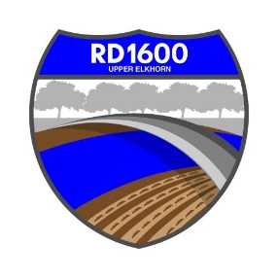

NOTICE OF REGULAR MEETING OF THE
BOARD OF TRUSTEES OF
RECLAMATION DISTRICT NO. 1600

Wednesday, March 6, 2024 @ 3:00 PM
NOTE LOCATION: Reclamation District 900
889 Drever St, West Sacramento

Call Meeting to Order

Public Comment on Non-Agenda items.

- Upper Elkhorn – Moving Yolo Bypass Levee Project
      - Presentation by Technical Team of the Upper Elkhorn Steering Committee – Overview of the Local Preferences Memorandum to be sent to US Army Corps of Engineers

Report by MBK Engineers on Maintenance and Related Matters

Flood System Repair Program (FSRP) for RD1600 patrol roadway repair

DWR roadway repair

Flood Maintenance Assistance Program (FMAP)

USACE Yolo Bypass Repair

Status of FEMA Claim for 2023 Flood

Update on Vegetation Control

Financial Statements Prepared by Dustin Dumars, CPA

Action Items

Approval of Minutes - Special Meeting 1.4.2024

Reports by Trustees

Update on Yolo Subbasin Groundwater Agency - Clark

- Scheduling Next Regular Meeting – proposed date and time:
June 5, 2024 at 3pm
- CLOSED SESSION: Conference with Legal Counsel – Anticipated Litigation. Significant exposure to litigation pursuant to subdivision (b) of Section 54956.9 (two cases)

Dated: March 1, 2024

PROOF OF POSTING NOTICE OF REGULAR MEETING

I am a citizen of the United States and a resident of Yolo County, California. I am over the age of eighteen years.

On ___________________, I posted within the boundaries of the District of RECLAMATION DISTRICT NO. 1600 the NOTICE OF SPECIAL MEETING OF RECLAMATION DISTRICT NO. 1600.

I declare under penalty of perjury under the laws of the State of California that the forgoing is true and correct.

AMMY REYES, Secretary
Board of Trustees, Reclamation District 1600

